Exercises: Objects, Associative Arrays, Maps, Sets
Problems for exercises and homework for the “JavaScript Fundamentals” course @ SoftUni. Submit your solutions in the SoftUni judge system at https://judge.softuni.bg/Contests/316/.
- Heroic Inventory
In the era of heroes, every hero has his own items which make him unique. Create a function which creates a register for the heroes, with their names, level, and items, if they have such. The register should accept data in a specified format, and return it presented in a specified format.
The input comes as array of strings. Each element holds data for a hero, in the following format:
“{heroName} / {heroLevel} / {item1}, {item2}, {item3}...”
You must store the data about every hero. The name is a string, the level is a number and the items are all strings.
The output is a JSON representation of the data for all the heroes you’ve stored. The data must be an array of all the heroes. Check the examples for more info.
Examples
Input | Output
Isacc / 25 / Apple, GravityGun  Derek / 12 / BarrelVest, DestructionSword  Hes / 1 / Desolator, Sentinel, Antara | [{"name":"Isacc","level":25,"items":["Apple","GravityGun"]},{"name":"Derek","level":12,"items":["BarrelVest","DestructionSword"]},{"name":"Hes","level":1,"items":["Desolator","Sentinel","Antara"]}]
Input | Output
Jake / 1000 / Gauss, HolidayGrenade | [{"name":"Jake","level":1000,"items":["Gauss","HolidayGrenade"]}]
Hints
- We need an array that will hold our hero data. That is the first thing we create.
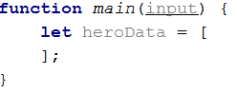
- Next, we need to loop over the whole input, and process it. Let’s do that with a simple for loop.
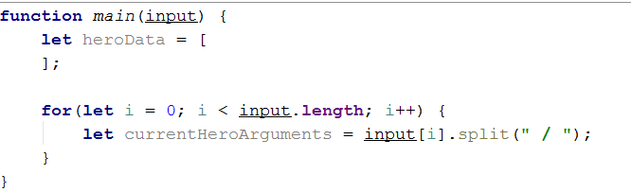
- Every element from the input holds data about a hero, however the elements from the data we need are separated by some delimiter, so we just split each string with that delimiter.
- Next, we need to take the elements from the string array, which is a result of the string split, and parse them.
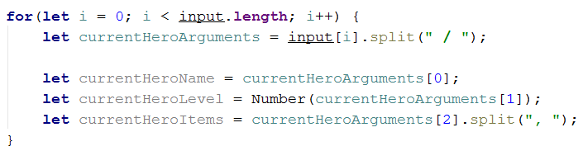
- However, if you do this, you could get quite the error in the current logic. If you go up and read the problem definition again, you will notice that there might be a case where the hero has no items; in that case, if we try to take the 3rd element of the currentHeroArguments array, it will result in an error. That is why we need to perform a simple check.
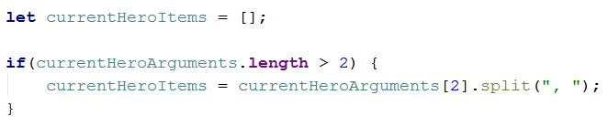
- If there are any items in the input, the variable will be set to the split version of them. If not, it will just remain an empty array, as it is supposed to.
- We have now extracted the needed data – we have stored the input name in a variable, we have parsed the given level to a number, and we have also split the items that the hero holds by their delimiter, which would result in a string array of elements. By definition, the items are strings, so we don’t need to process the array we’ve made anymore.
- Now what is left is to add that data into an object and add that object to the array.
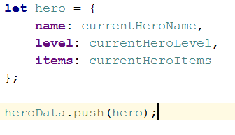
- Lastly, we need to turn the array of objects we have made, into a JSON string, which is done by the JSON.stringify() function

- JSON’s Table
JSON’s Table is a magical table which turns JSON data into an HTML table. You will be given JSON strings holding data about employees, including their name, position and salary. You need to parse that data into objects, and create an HTML table which holds the data for each employee on a different row, as columns.
The name and position of the employee are strings, the salary is a number.
The input comes as array of strings. Each element is a JSON string which represents the data for a certain employee.
The output is the HTML code of a table which holds the data exactly as explained above. Check the examples for more info.

Examples
Input | Output
{"name":"Pesho","position":"Promenliva","salary":100000}  {"name":"Teo","position":"Lecturer","salary":1000}  {"name":"Georgi","position":"Lecturer","salary":1000} | <table>  <tr>  <td>Pesho</td>  <td>Promenliva</td>  <td>100000</td>  <tr>  <tr>  <td>Teo</td>  <td>Lecturer</td>  <td>1000</td>  <tr>  <tr>  <td>Georgi</td>  <td>Lecturer</td>  <td>1000</td>  <tr>  </table>
Hints
- You might want to escape the HTML. Otherwise you might find yourself victim to vicious JavaScript code in the input, which aims only to hack you.
- Cappy Juice
You will be given different juices, as strings. You will also receive quantity as a number. If you receive a juice, you already have, you must sum the current quantity of that juice, with the given one. When a juice reaches 1000 quantity, it produces a bottle. You must store all produced bottles and you must print them at the end.
Note: 1000 quantity of juice is one bottle. If you happen to have more than 1000, you must make as much bottles as you can, and store what is left from the juice.
Example: You have 2643 quantity of Orange Juice – this is 2 bottles of Orange Juice and 643 quantity left.
The input comes as array of strings. Each element holds data about a juice and quantity in the following format:
“{juiceName} => {juiceQuantity}”
The output is the produced bottles. The bottles are to be printed in order of obtaining the bottles. Check the second example bellow - even though we receive the Kiwi juice first, we don’t form a bottle of Kiwi juice until the 4th line, at which point we have already create Pear and Watermelon juice bottles, thus the Kiwi bottles appear last in the output.
Examples
Input | Output |  | Input | Output
Orange => 2000  Peach => 1432  Banana => 450  Peach => 600  Strawberry => 549 | Orange => 2  Peach => 2 |  | Kiwi => 234  Pear => 2345  Watermelon => 3456  Kiwi => 4567  Pear => 5678  Watermelon => 6789 | Pear => 8  Watermelon => 10  Kiwi => 4

- Store Catalogue
You have to create a sorted catalogue of store products. You will be given the products’ names and prices. You need to order them by alphabetical order.
The input comes as array of strings. Each element holds info about a product in the following format:
“{productName} : {productPrice}”
The product’s name will be a string, which will always start with a capital letter, and the price will be a number. You can safely assume there will be NO duplicate product input. The comparison for alphabetical order is case-insensitive.
As output you must print all the products in a specified format. They must be ordered exactly as specified above. The products must be divided into groups, by the initial of their name. The group’s initial should be printed, and after that the products should be printed with 2 spaces before their names. For more info check the examples.
Examples
Input | Output |  | Input | Output
Appricot : 20.4  Fridge : 1500  TV : 1499  Deodorant : 10  Boiler : 300  Apple : 1.25  Anti-Bug Spray : 15  T-Shirt : 10 | A  Anti-Bug Spray: 15  Apple: 1.25  Appricot: 20.4  B  Boiler: 300  D  Deodorant: 10  F  Fridge: 1500  T  T-Shirt: 10  TV: 1499 |  | Banana : 2  Rubic's Cube : 5  Raspberry P : 4999  Rolex : 100000  Rollon : 10  Rali Car : 2000000  Pesho : 0.000001  Barrel : 10 | B  Banana: 2  Barrel: 10  P  Pesho: 0.000001  R  Rali Car: 2000000  Raspberry P: 4999  Rolex: 100000  Rollon: 10  Rubic's Cube: 5
- Auto-Engineering Company
You are tasked to create a register for a company that produces cars. You need to store how many cars have been produced from a specified model of a specified brand.
The input comes as array of strings. Each element holds information in the following format:
“{carBrand} | {carModel} | {producedCars}”
The car brands and models are strings, the produced cars are numbers. If the car brand you’ve received already exists, just add the new car model to it with the produced cars as its value. If even the car model exists, just add the given value to the current one.
As output you need to print – for every car brand, the car models, and number of cars produced from that model. The output format is:
“{carBrand}
###{carModel} -> {producedCars}
###{carModel2} -> {producedCars}
...”
The order of printing is the order in which the brands and models first appear in the input. The first brand in the input should be the first printed and so on. For each brand, the first model received from that brand, should be the first printed and so on.
Examples
Input | Output
Audi | Q7 | 1000  Audi | Q6 | 100  BMW | X5 | 1000  BMW | X6 | 100  Citroen | C4 | 123  Volga | GAZ-24 | 1000000  Lada | Niva | 1000000  Lada | Jigula | 1000000  Citroen | C4 | 22  Citroen | C5 | 10 | Audi  ###Q7 -> 1000  ###Q6 -> 100  BMW  ###X5 -> 1000  ###X6 -> 100  Citroen  ###C4 -> 145  ###C5 -> 10  Volga  ###GAZ-24 -> 1000000  Lada  ###Niva -> 1000000  ###Jigula -> 1000000
Hints
- The Map structure should be perfect for this problem.
- System Components
You will be given a register of systems with components and subcomponents. You need to build an ordered database of all the elements that have been given to you.
The elements are registered in a very simple way. When you have processed all of the input data, you must print them in a specific order. For every System you must print its components in a specified order, and for every Component, you must print its Subcomponents in a specified order.
The Systems you’ve stored must be ordered by amount of components, in descending order, as first criteria, and by alphabetical order as second criteria. The Components must be ordered by amount of Subcomponents, in descending order.
The input comes as array of strings. Each element holds data about a system, a component in that system, and a subcomponent in that component. If the given system already exists, you should just add the new component to it. If even the component exists, you should just add the new subcomponent to it. The subcomponents will always be unique. The input format is:
“{systemName} | {componentName} | {subcomponentName}”
All of the elements are strings, and can contain any ASCII character. The string comparison for the alphabetical order is case-insensitive.
As output you need to print all of the elements, ordered exactly in the way specified above. The format is:
“{systemName}
|||{componentName}
|||{component2Name}
||||||{subcomponentName}
||||||{subcomponent2Name}
{system2Name}
...”
Examples
Input | Output
SULS | Main Site | Home Page  SULS | Main Site | Login Page  SULS | Main Site | Register Page  SULS | Judge Site | Login Page  SULS | Judge Site | Submittion Page  Lambda | CoreA | A23  SULS | Digital Site | Login Page  Lambda | CoreB | B24  Lambda | CoreA | A24  Lambda | CoreA | A25  Lambda | CoreC | C4  Indice | Session | Default Storage  Indice | Session | Default Security | Lambda  |||CoreA  ||||||A23  ||||||A24  ||||||A25  |||CoreB  ||||||B24  |||CoreC  ||||||C4  SULS  |||Main Site  ||||||Home Page  ||||||Login Page  ||||||Register Page  |||Judge Site  ||||||Login Page  ||||||Submittion Page  |||Digital Site  ||||||Login Page  Indice  |||Session  ||||||Default Storage  ||||||Default Security
Hints
- Creating a sorting function with two criteria might seem a bit daunting at first, but it can be simplified to the following:
- If elements a and b are different based on the first criteria, then that result is the result of the sorting function, checking the second criteria is not required.
- If elements a and b are equal based on the first criteria, then the result of comparing a and b on the second criteria is the result of the sorting.
- Usernames
You are tasked to create a catalogue of usernames. The usernames will be strings that may contain any ASCII character. You need to order them by their length, in ascending order, as first criteria, and by alphabetical order as second criteria.
The input comes as array of strings. Each element represents a username. Sometimes the input may contain duplicate usernames. Make it so that there are NO duplicates in the output.
The output is all of the usernames, ordered exactly as specified above – each printed on a new line.
Examples
Input | Output |  | Input | Output
Ashton  Kutcher  Ariel  Lilly  Keyden  Aizen  Billy  Braston | Aizen  Ariel  Billy  Lilly  Ashton  Keyden  Braston  Kutcher |  | Denise  Ignatius  Iris  Isacc  Indie  Dean  Donatello  Enfuego  Benjamin  Biser  Bounty  Renard  Rot | Rot  Dean  Iris  Biser  Indie  Isacc  Bounty  Denise  Renard  Enfuego  Benjamin  Ignatius  Donatello
Hints
- Try to find a structure which does NOT allow duplicates, it will be best for the current problem.
- *Unique Sequences
You are tasked with storing sequences of numbers. You will receive an unknown amount of arrays containing numbers from which you must store only the unique arrays (duplicate arrays should be discarded). An array is considered the same (NOT unique) if it contains the same numbers as another array, regardless of their order.
After storing all arrays, your program should print them back in ascending order based on their length, if two arrays have the same length they should be printed in order of being received from the input. Each individual array should be printed in descending order in the format "[a₁, a₂, a₃,… a_{n}]". Check the examples bellow.
The input comes as an array of strings where each entry is a JSON representing an array of numbers.
The output should be printed on the console - each array printed on a new line in the format "[a₁, a₂, a₃,… a_{n}]" , following the above mentioned ordering.
Examples
Input | Output
[-3, -2, -1, 0, 1, 2, 3, 4]  [10, 1, -17, 0, 2, 13]  [4, -3, 3, -2, 2, -1, 1, 0] | [13, 10, 2, 1, 0, -17]  [4, 3, 2, 1, 0, -1, -2, -3]

Input | Output
[7.14, 7.180, 7.339, 80.099]  [7.339, 80.0990, 7.140000, 7.18]  [7.339, 7.180, 7.14, 80.099] | [80.099, 7.339, 7.18, 7.14]
Hints
- Think of an easy way to compare arrays.
- Sometimes the most obvious collection choice is not the best one.

